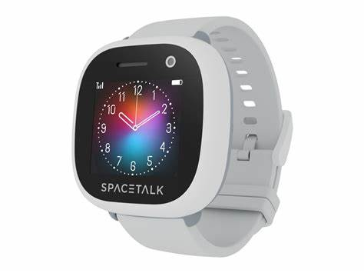Spacetalk

Description: The **Spacetalk Adventurer** is one of the most popular models for children. It functions as a **4G smartwatch and phone** with **GPS tracking**, allowing parents to monitor their child's location in real-time using the **Spacetalk app**. The watch supports **two-way calling and messaging**, but only with pre-approved contacts, ensuring kids stay safe from unknown numbers or unwanted calls.

One of its standout features is **School Mode**, which disables certain functions during school hours, allowing children to focus on learning while still having emergency access. The watch also includes **fitness tracking, weather updates**, and an **SOS alert button**, providing extra peace of mind for parents. For older kids and teenagers, Spacetalk offers the **Spacetalk Life** smartwatch. It maintains the same core safety and communication features as the Adventurer but with a more mature design. This model is great for **independent teenagers** who need a reliable way to stay in touch with family without the distractions of a traditional smartphone